### problem statement
Enable continuous monitoring of EC2 instance performance and Docker container health by automating metric collection and pushing data to AWS CloudWatch for alerting and visualization.

### step 1
- go to IAM > roles > create role
- select ec2 in use case
- Make sure `CloudWatchAgentServerPolicy` is added
- provide role name and description(optional) 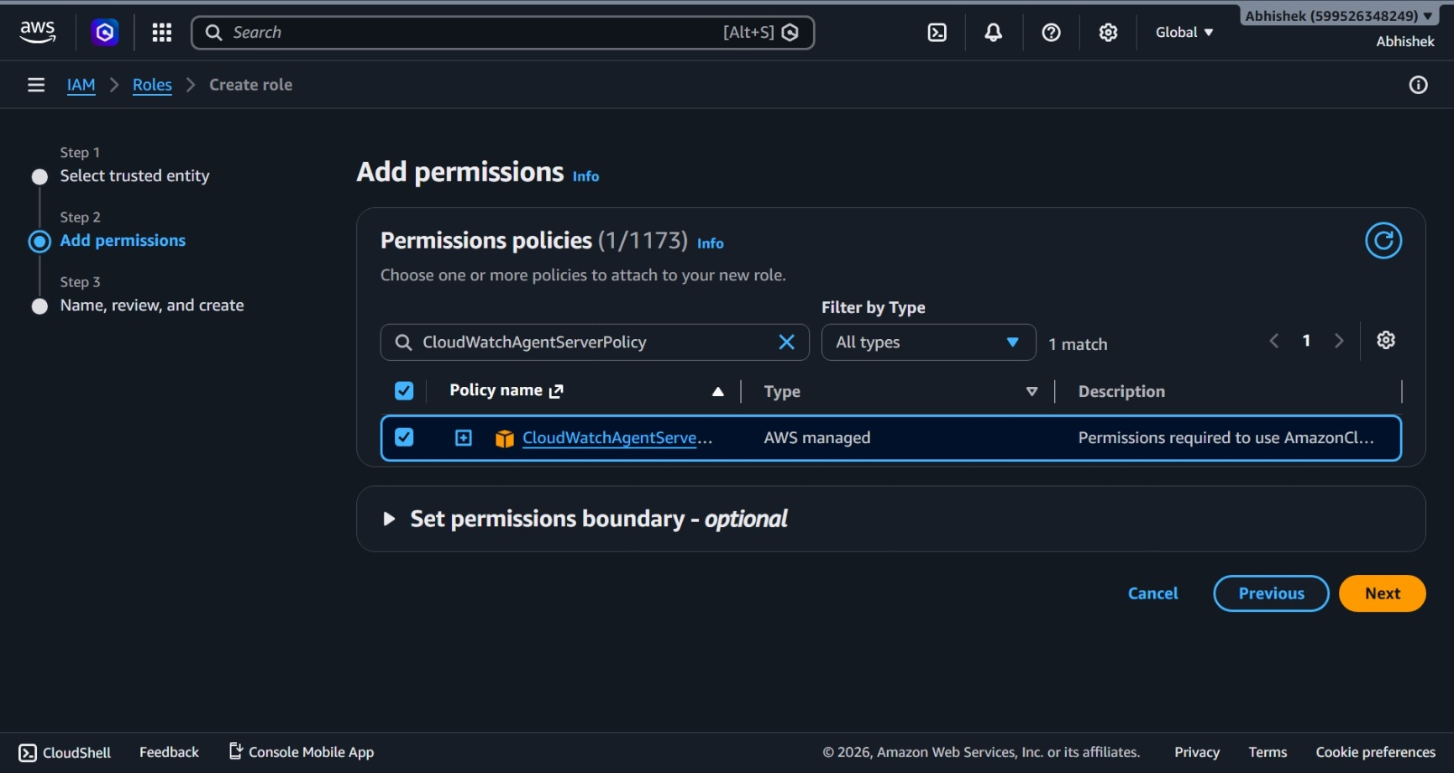
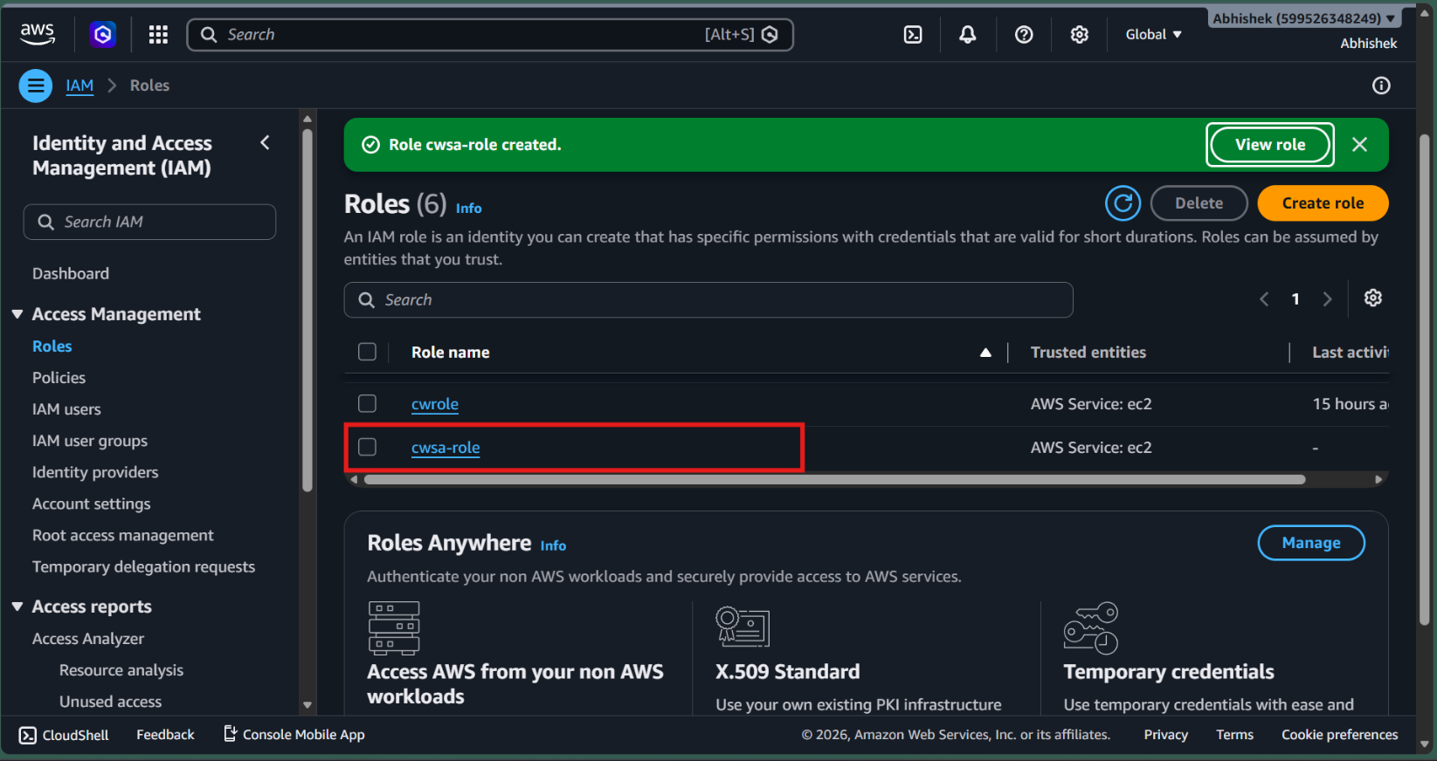
### step 2
- create an ec2 instance
- make sure the role is attached to the ec2 instance
- Go to advanced details > IAM Instance profile
- select the role from there
- and then launch the instance and connect to the instance
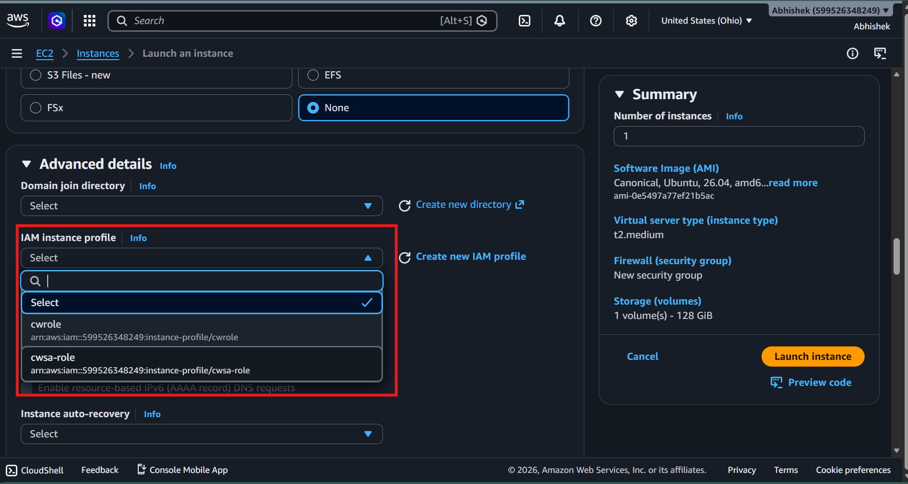

### step 3
- once connected run the following commands to update the system
- > sudo apt update && sudo apt upgrade -y

### step 4
- install docker, run the following commands...

- > sudo apt install docker.io -y
- > sudo usermod -aG docker $USER
- > newgrp docker

- then run `docker ps` to check if it's working and have the permission
- install aws cli
-> sudo apt install awscli -y
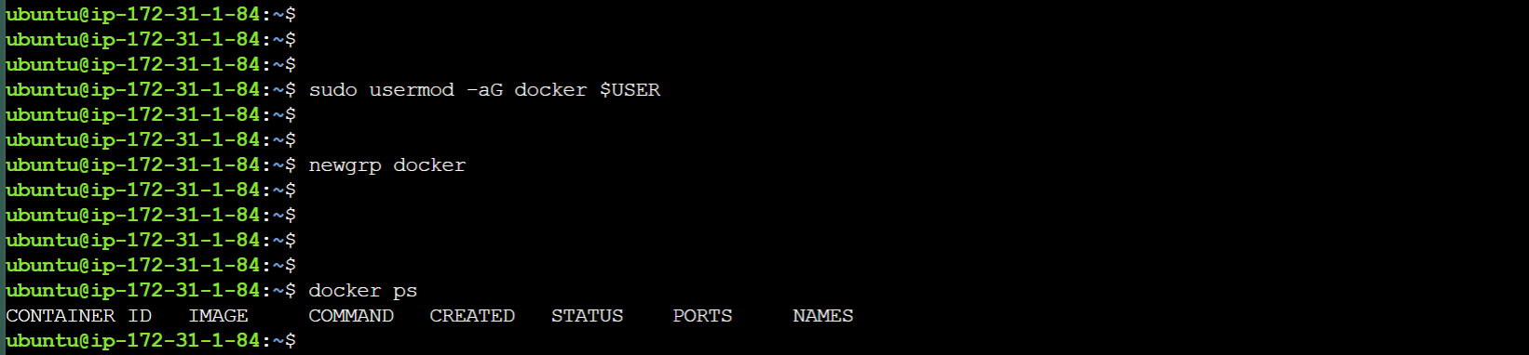

### step 5
- To connect Amazon CloudWatch to an EC2 instance to monitor its metrics, you need to install and configure the Amazon CloudWatch Agent on the instance
- for ubuntu
`wget https://amazoncloudwatch-agent.s3.amazonaws.com/ubuntu/amd64/latest/amazon-cloudwatch-agent.deb
sudo dpkg -i -E ./amazon-cloudwatch-agent.deb`
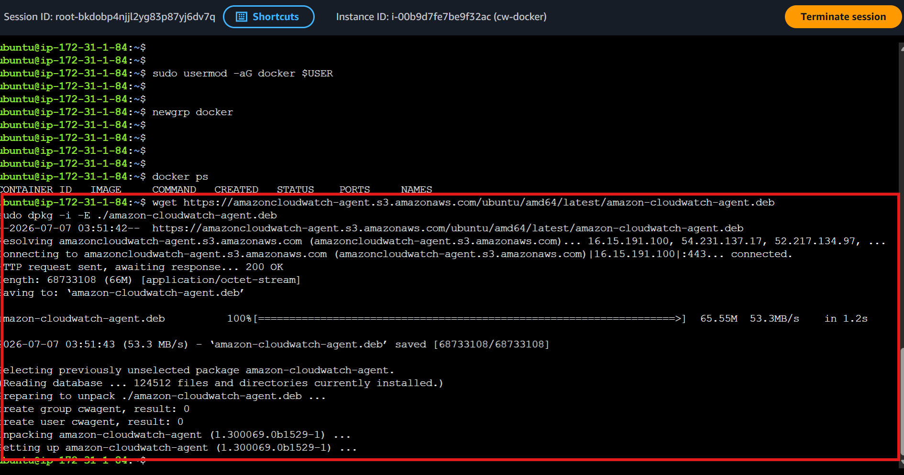

### step 6
- Now configure the cloudWatch agent easily by running the following command
- > sudo /opt/aws/amazon-cloudwatch-agent/bin/amazon-cloudwatch-agent-config-wizard
- user to run the agent, choose `cwagent` if you plan to monitor standard system performance like cpu, memory, RAM and disk utility or `root` if you need to collect application logs or system logs
- configure wizard makes configuring agent easily by just answering the quesion and choosing an option
- you can change the configuration later on at `/opt/aws/amazon-cloudwatch-agent/bin/config.json`

### step 7
- start the agent by running the follwing command
- > sudo /opt/aws/amazon-cloudwatch-agent/bin/amazon-cloudwatch-agent-ctl -a fetch-config -m ec2 -s -c file:/opt/aws/amazon-cloudwatch-agent/bin/config.json
- to check the status, run
- > sudo /opt/aws/amazon-cloudwatch-agent/bin/amazon-cloudwatch-agent-ctl -a status
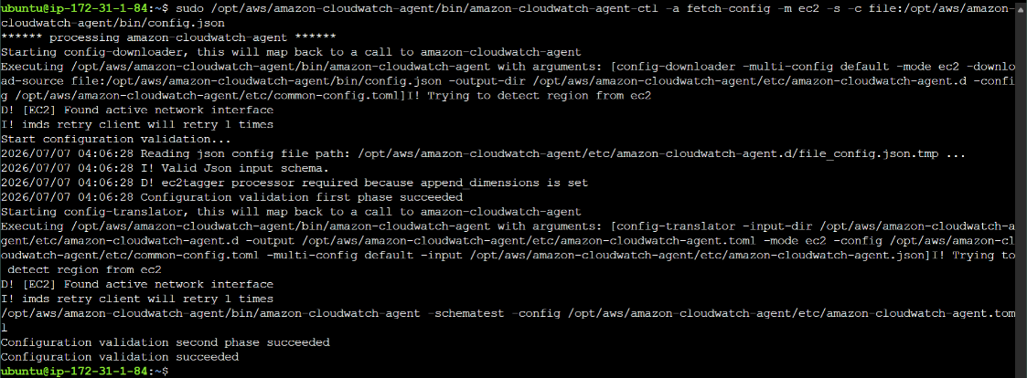
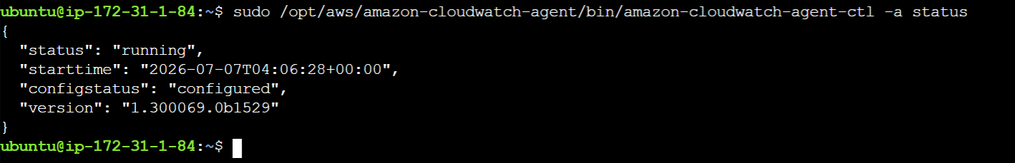

### step 8
- after few minutes, check metrics in cloudWatch
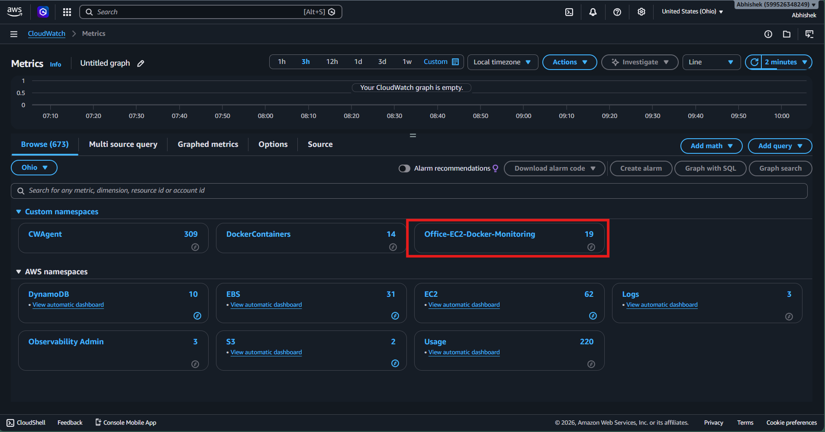

### step 9
- run nginx container using the following command
- > docker run -d --name nginx -p 80:80 nginx
- once the container starts running
- check
> docker stats

### step 10
- create a script that sends data to the cloud watch
```bash
#!/bin/bash

# 1. Fetch the IMDSv2 Session Token (Required for secure EC2 environments)
TOKEN=$(curl -s -X PUT "http://169.254.169.254/latest/api/token" -H "X-aws-ec2-metadata-token-ttl-seconds: 21600")

# 2. Extract Instance ID and Region using the token
INSTANCE_ID=$(curl -s -H "X-aws-ec2-metadata-token: $TOKEN" http://169.254.169.254/latest/meta-data/instance-id)
AZ=$(curl -s -H "X-aws-ec2-metadata-token: $TOKEN" http://169.254.169.254/latest/meta-data/placement/availability-zone)

# Strip the trailing letter from the Availability Zone to get the base region (e.g., us-east-2a -> us-east-2)
REGION=$(echo "$AZ" | sed 's/[a-z]$//')

# 3. Stream Docker container stats to CloudWatch
docker stats --no-stream --format "{{.Name}} {{.CPUPerc}} {{.MemPerc}}" | while read -r name cpu mem; do

# Strip the '%' sign from the string percentages
cpu_val=$(echo "$cpu" | sed 's/%//')
mem_val=$(echo "$mem" | sed 's/%//')

if [ -z "$cpu_val" ] || [ -z "$mem_val" ]; then
continue
fi

# Push CPU Metric
aws cloudwatch put-metric-data --namespace "DockerContainers" \
--metric-name "ContainerCPUUtilization" \
--dimensions InstanceId="$INSTANCE_ID",ContainerName="$name" \
--value "$cpu_val" --unit "Percent" --region "$REGION"

# Push Memory Metric
aws cloudwatch put-metric-data --namespace "DockerContainers" \
--metric-name "ContainerMemoryUtilization" \
--dimensions InstanceId="$INSTANCE_ID",ContainerName="$name" \
--value "$mem_val" --unit "Percent" --region "$REGION"
done
```

### step 11
- create a cronjob so that the bash runs every minute and sends data to the cloud watch
- run the following commands
- > crontab -e
- add this line in the end
- > ***** /home/ubuntu/dev/metrics.sh > /home/ubuntu/dev/logs/cronlogs.logs >2&1

### step 12
- run a ubuntu contianer with stress-ng
- `stress-ng` is tool used to put load on the machines.
- run the follwing command
- > docker run -d --name cpu-hog --cpus="0.75" ubuntu sh -c "apt-get update && apt-get install -y stress-ng && stress-ng --cpu 1 --cpu-load 100"

### step 13
- Go to Browse, select the metrics and then click create alaram
- select the metrics, threshold ans SNS topic
- once metrics reaches the threshold , you will be notified

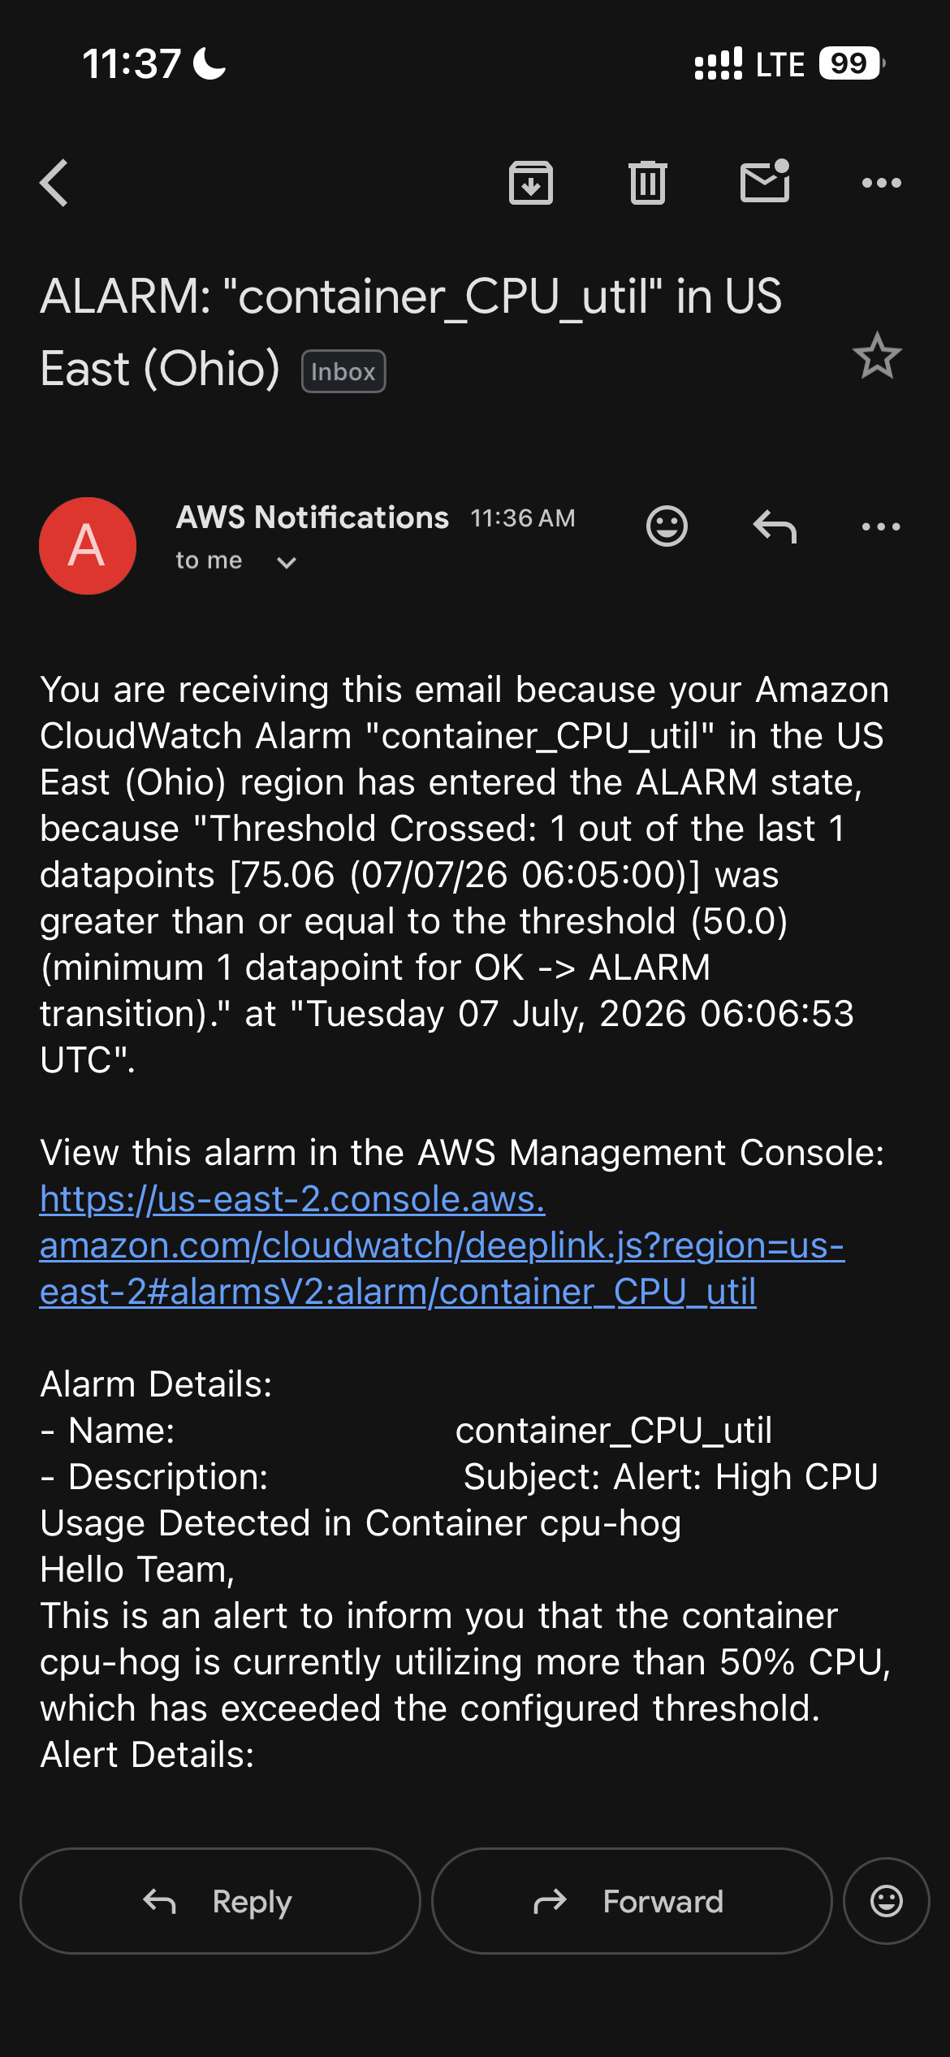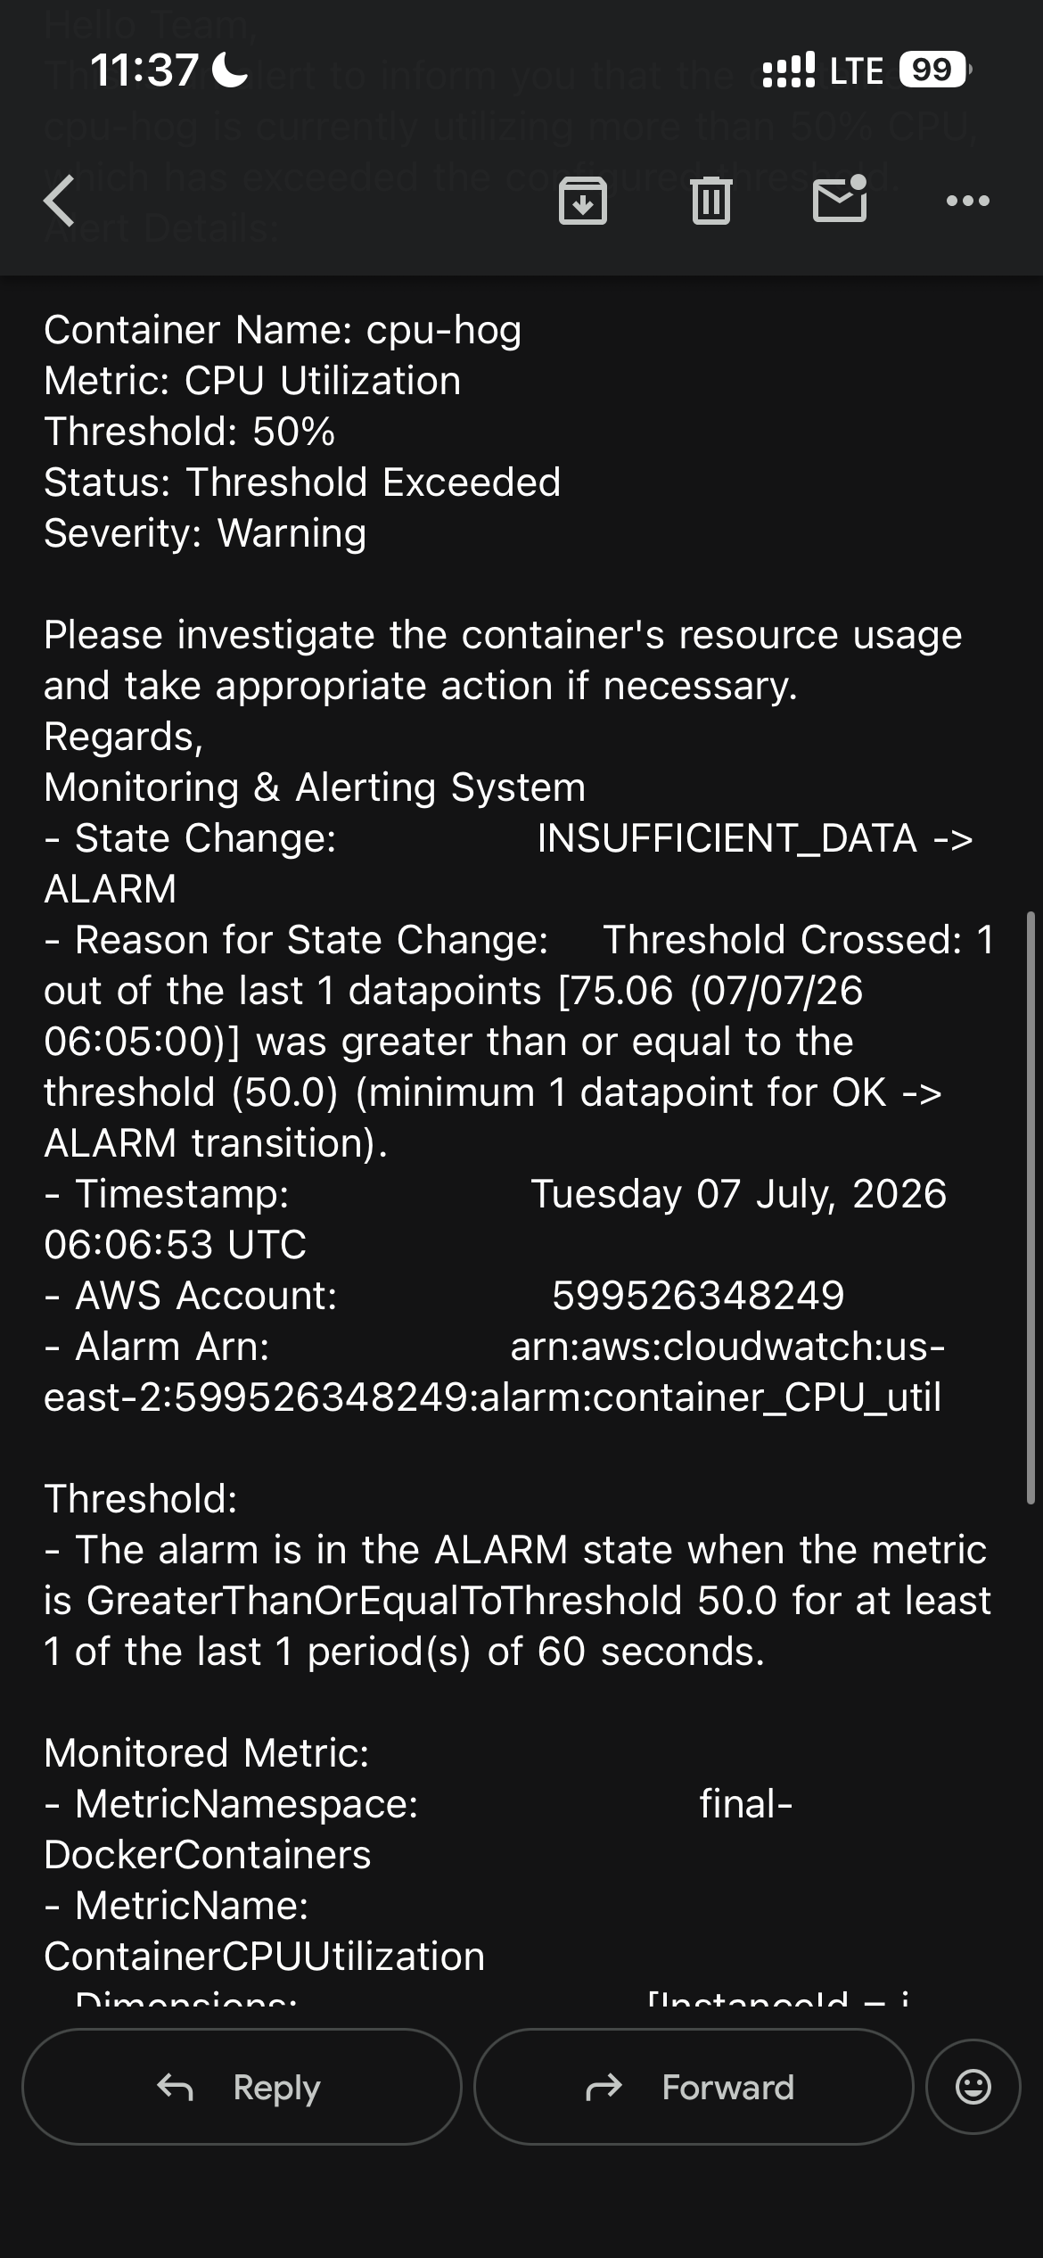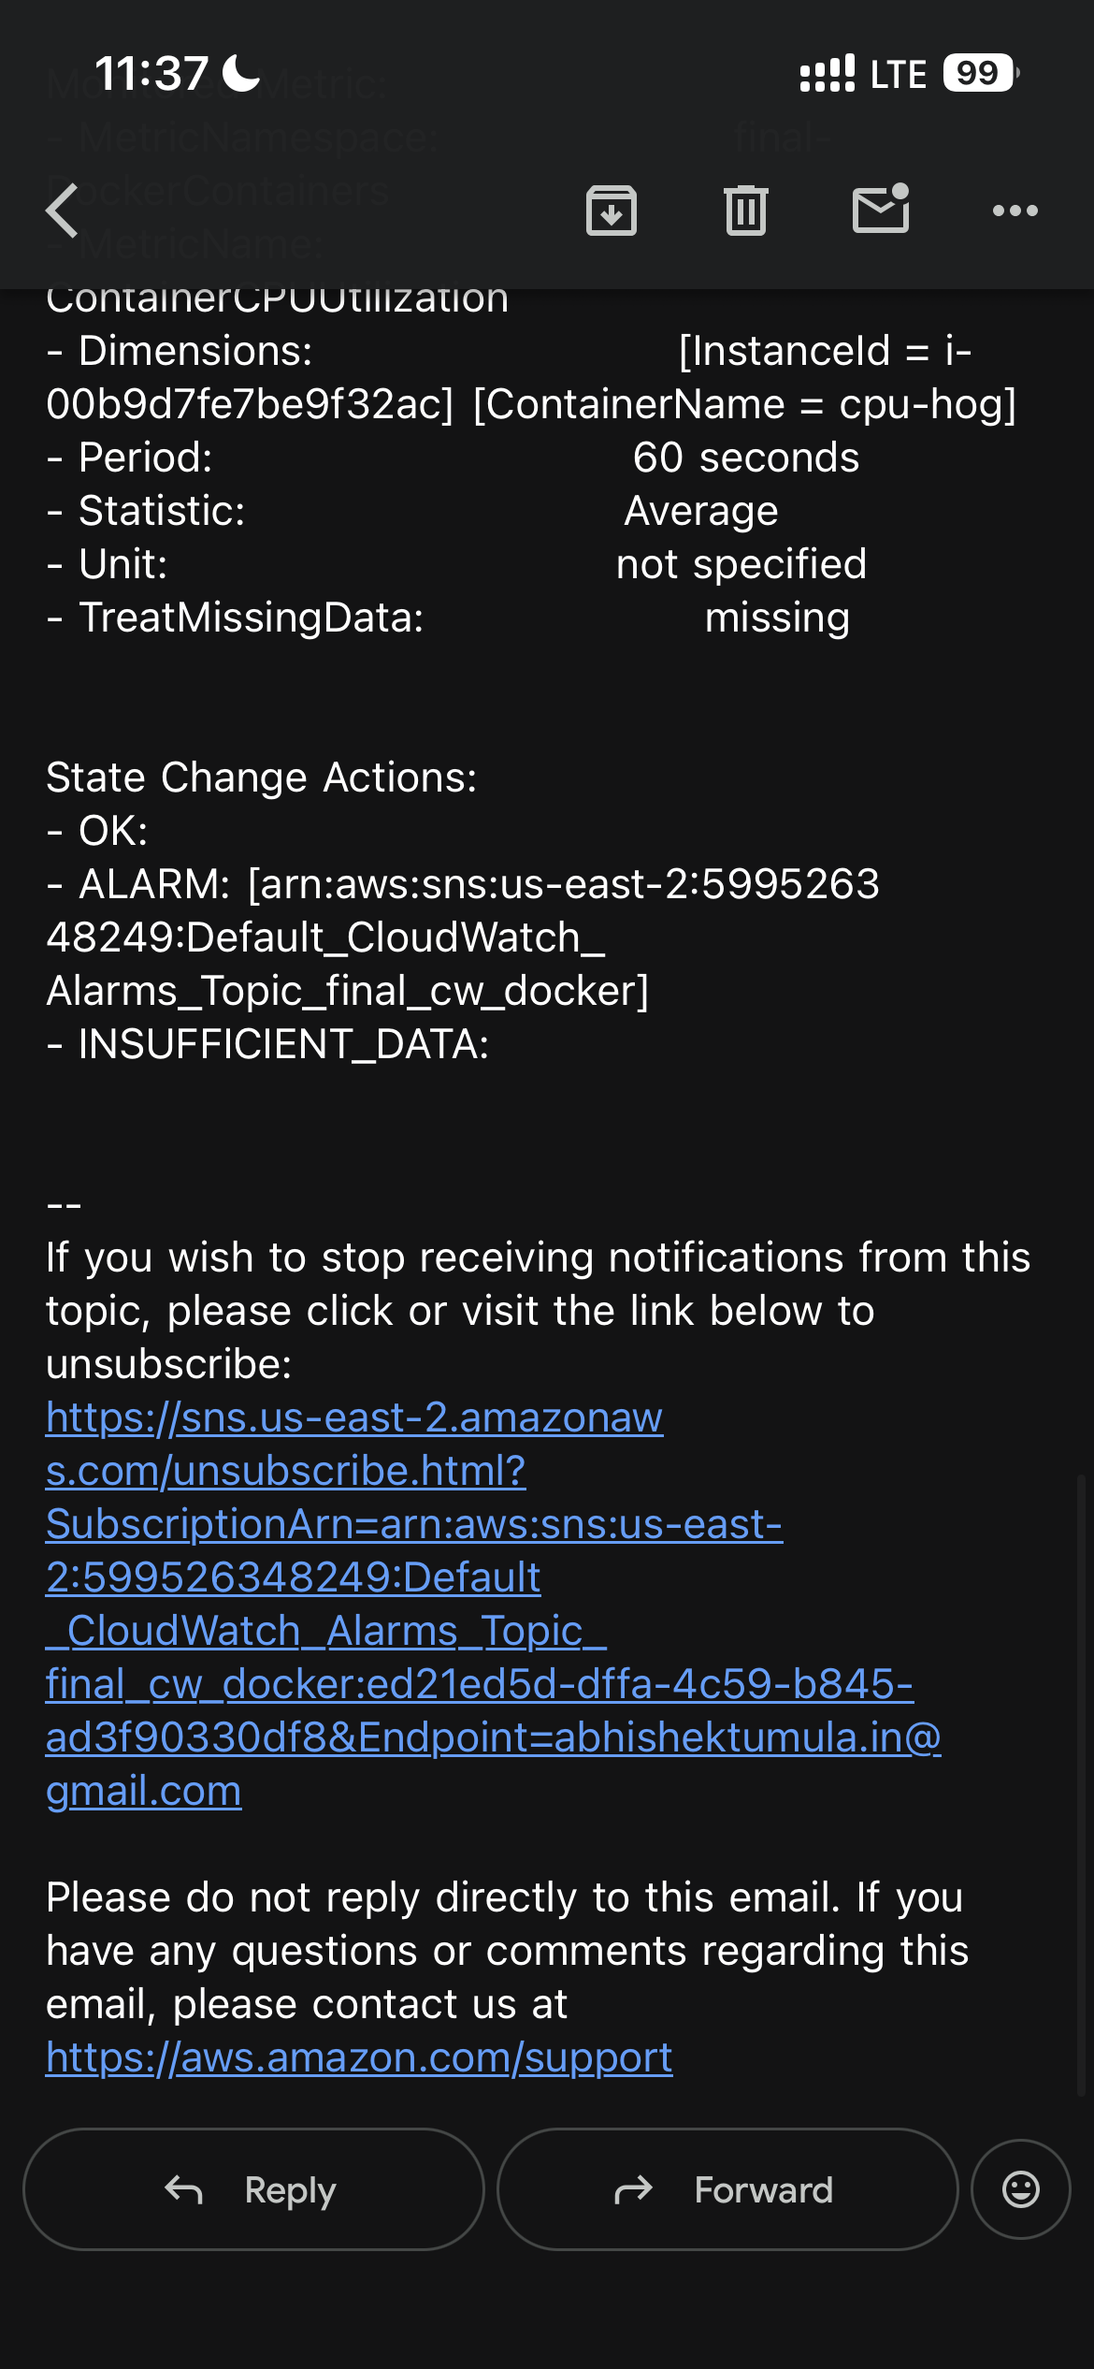
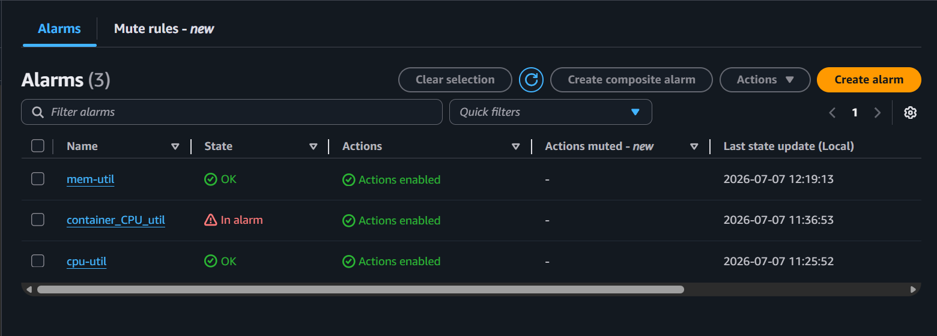

### step 14
- create a dashboard
- cloudWatch > dashboard > create >
- select the type, metrics and then place it in the dasboard
- save it

